

LIST OF EQUATIONS and Errata

Rocket Propulsion by Heister Chapter 1 to 4



MAE440/540 FA20

University of Alabama in Huntsville

# **Chapter 1**

|  |  |  |
| --- | --- | --- |
|  |  |  |
|  | Equation 2.2 is recommended approach | 1.1 |
|  |  | 1.2 |
|  | Equation 2.4 is the recommended approach | 1.3 |
|  |  | 1.4 |

# **Chapter 2**

|  |  |  |
| --- | --- | --- |
|  |  |  |
|  |  | 2.1 |
|  |  | 2.2 |
|  |  | 2.3 |
|  |  | 2.4 |
|  |  | 2.5 |
|  |  | 2.6 |
|  |  | 2.7 |
|  |  | 2.8 |
|  |  | 2.9 |
|  |  | 2.10 |
|  |  | 2.11 |
|  |  | 2.12 |
|  |  | 2.13 |
|  |  | 2.14 |
|  |  | 2.15 |
|  |  | 2.16 |
|  |  | 2.17 |
|  |  | 2.18 |
|  |  | 2.19 |
|  |  | 2.20 |
|  |  | 2.21 |
|  |  | 2.22 |
|  |  | 2.23 |
|  |  | 2.24 |
|  |  | 2.25 |
|  |  | 2.26 |
|  |  | 2.27 |
|  |  | 2.28 |
|  |  | 2.29 |
|  |  | 2.30 |
|  |  | 2.31 |
|  |  | 2.32 |
|  |  | 2.33 |

# **Chapter 3**

|  |  |  |
| --- | --- | --- |
|  |  |  |
|  |  | 3.1 |
|  |  | 3.2 |
|  |  | 3.3 |
|  |  | 3.4 |
|  |  | 3.5 |
|  |  | 3.6 |
|  |  | 3.7 |
|  |  | 3.8 |
|  |  | 3.9 |
|  |  | 3.10 |
|  |  | 3.11 |
|  |  | 3.12 |
|  |  | 3.13 |
|  |  | 3.14 |
|  | The equation as presented is incorrect | 3.15 |
|  |  | 3.16 |
|  | Should be | 3.17 |
|  |  | 3.18 |
|  |  | 3.19 |
|  |  | 3.20 |
|  |  | 3.21 |
|  |  | 3.22 |
|  |  | 3.23 |
|  |  | 3.24 |
|  |  | 3.25 |
|  |  | 3.26 |
|  |  | 3.27 |
|  |  | 3.28 |
|  | Equation incorrect in the book  Last term should be | 3.29 |
|  |  | 3.30 |
|  |  | 3.31 |
|  |  | 3.32 |
|  |  | 3.33 |
|  |  | 3.34 |
|  |  | 3.35 |
|  |  | 3.36 |
|  |  | 3.37 |
|  |  | 3.38 |
|  |  | 3.39 |
|  |  | 3.40 |
|  |  | 3.41 |
|  |  | 3.42 |
|  |  | 3.43 |
|  |  | 3.44 |
|  |  | 3.45 |
|  |  | 3.46 |
|  |  | 3.47 |
|  |  | 3.48 |
|  |  | 3.49 |
|  |  | 3.50 |
|  |  | 3.51 |

# **Chapter 4**

|  |  |  |
| --- | --- | --- |
|  |  |  |
|  |  | 4.1 |
|  |  | 4.2 |
|  |  | 4.3 |
|  |  | 4.4 |
|  |  | 4.5 |
|  |  | 4.6 |
|  |  | 4.7 |
|  |  | 4.8 |
|  |  | 4.9 |
|  |  | 4.10 |
|  |  | 4.11 |
|  |  | 4.12 |
|  |  | 4.13 |
|  |  | 4.14 |
|  |  | 4.15 |
|  |  | 4.16 |
|  |  | 4.17 |
|  |  | 4.18 |
|  |  | 4.19 |
|  |  | 4.20 |
|  |  | 4.21 |
|  |  | 4.22 |
|  |  | 4.23 |
|  |  | 4.24 |
|  |  | 4.25 |
|  |  | 4.26 |
|  |  | 4.27 |
|  |  | 4.28 |
|  |  | 4.29 |
|  | Incorrect English unit presentation (See below) | 4.30 |
|  |  | 4.31 |
|  |  | 4.32 |
|  |  | 4.33 |
|  |  | 4.34 |
|  |  | 4.35 |
|  |  | 4.36 |
|  |  | 4.37 |
|  |  | 4.38 |
|  |  | 4.39 |
|  |  | 4.40 |
|  |  | 4.41 |
|  |  | 4.42 |
|  |  | 4.43 |
|  |  | 4.44 |
|  |  | 4.45 |
|  |  | 4.46 |
|  |  | 4.47 |
|  |  | 4.48 |
|  |  | 4.49 |
|  |  | 4.50 |
|  |  | 4.51 |
|  |  | 4.52 |
|  |  | 4.53 |
|  |  | 4.54 |
|  |  | 4.55 |
|  |  | 4.56 |
|  |  | 4.57 |
|  |  | 4.58 |
|  |  | 4.59 |
|  |  | 4.60 |
|  |  | 4.61 |
|  |  | 4.62 |
|  |  | 4.63 |
|  |  | 4.64 |
|  |  | 4.65 |
|  |  | 4.66 |
|  |  | 4.67 |
|  |  | 4.68 |
|  |  | 4.69 |

CHAPTER 5

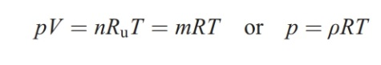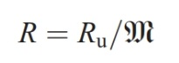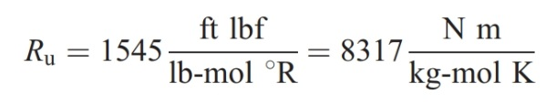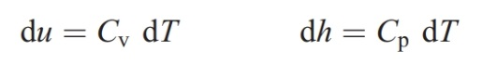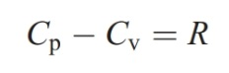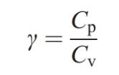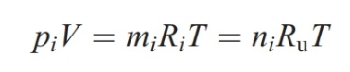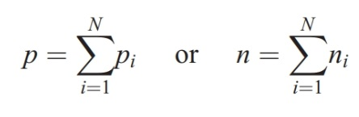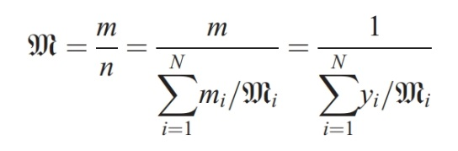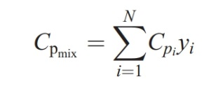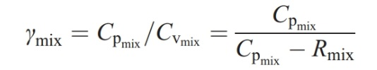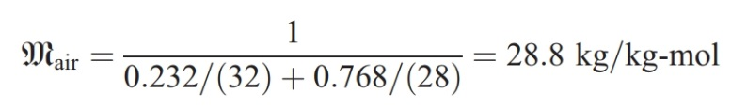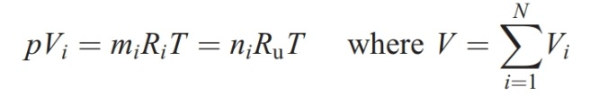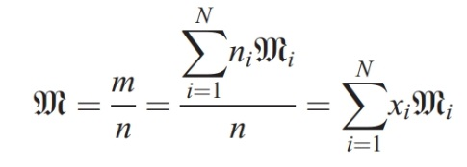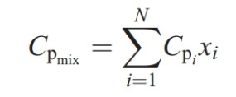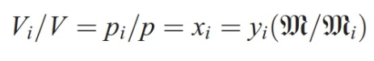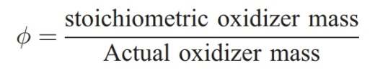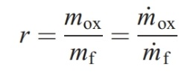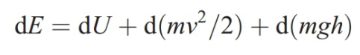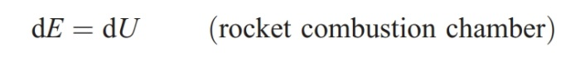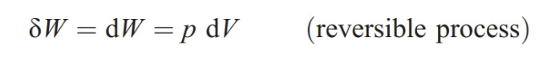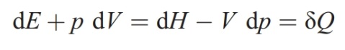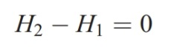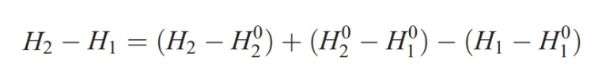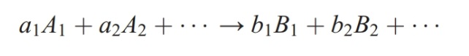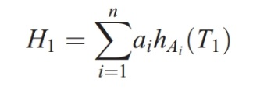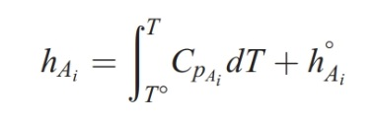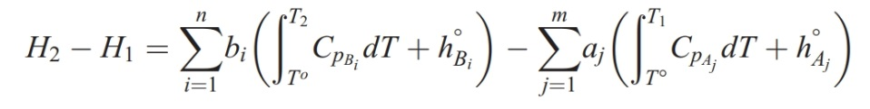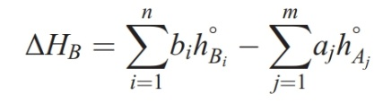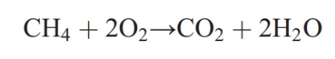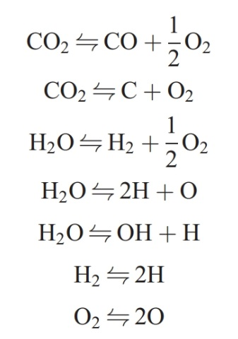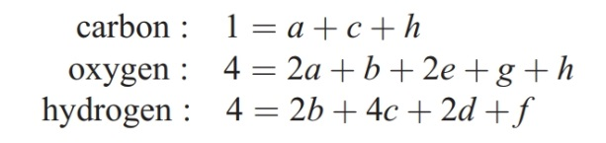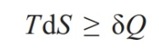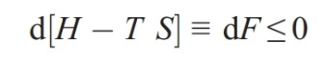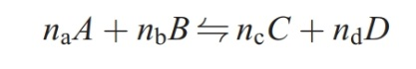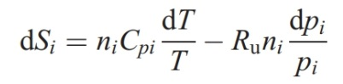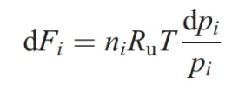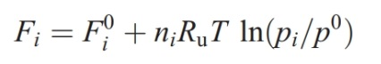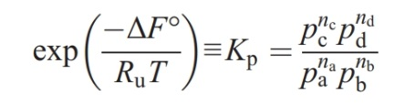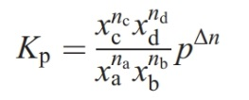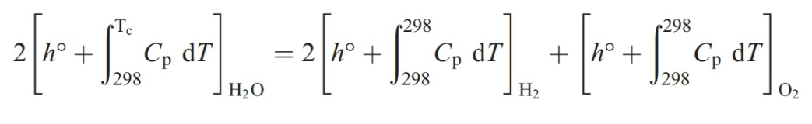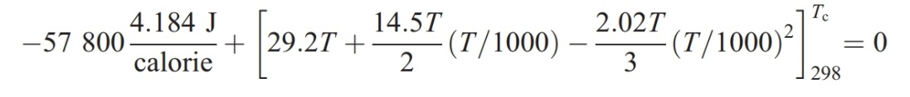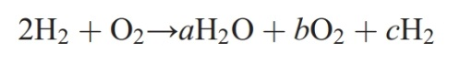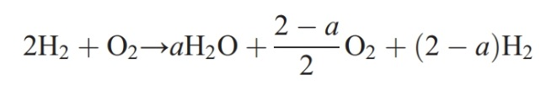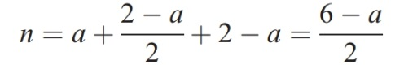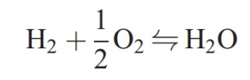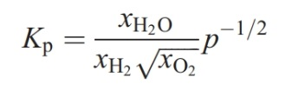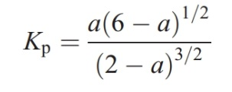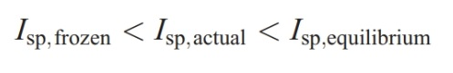

CHAPTER 11

Some equations. Note corrections discussed in lecture

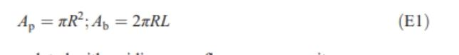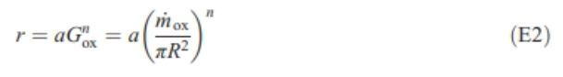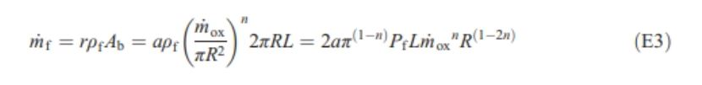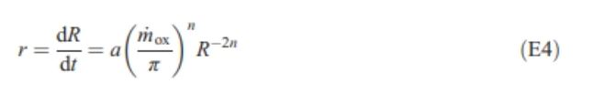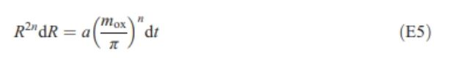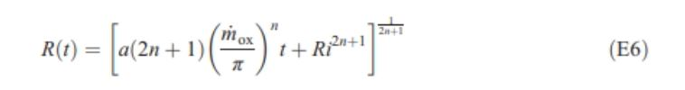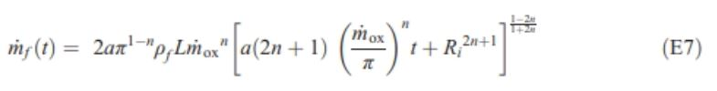

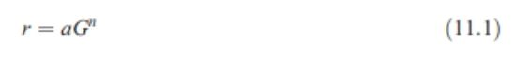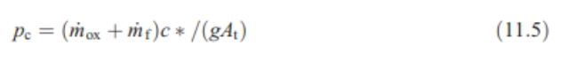

|  | **Book Page** | **Detailed Description of Error** | **Detailed Recommendation of Replacement** |
| --- | --- | --- | --- |
|  |  | **CHAPTER 1** |  |
| 1 | 2 | In last sentence, “Herman Obert” | Should be “Herman Oberth” |
| 2 | 8 | Table 1.1 has [ropellant | Should say “propellant” |
| 3 | 11 | “As we shall see in Chapter 6.” | Should read “As we shall see in Chapter 7” |
| 4 | 13 | “... engine power cycles will be examined in Chapter 7.” | Should read ““... engine power cycles will be examined in Chapter 8” |
| 5 | 13 | The 3rd paragraph, it says that Figure 1.9 shows a pressure-fed LRE arrangement. Figure 1.9 is a previously referenced gas generator cycle, and there is no schematic here for a pressure-fed arrangement. | The figure for a pressure-fed arrangement needs to be added in and referenced with the right figure number. |
|  |  | **CHAPTER2** |  |
| 1 | 21 | *Concept Recommendation*: Equation 2.2 (and equation 1.4 and 3.11) for the structural efficiency. It does say masses associated with the propulsion system. On first read, I got this associated with vehicle propellant mass fraction from Sutton (my own baggage) and had to undo that as I read forward. This quantity can easily be confused with *K* in this book. | *Recommendation:* Stress that this parameter is strictly for the propulsion systems and does not consider the payload. |
| 2 | 22 | No comma after “not” in step 6 | Needs comma after “not” in step 6 |
| 3 | 25 | Figure 2.1 and the discussion depicts ‘the centripetal force (*Fc*)..” | I believe if *Fc* = *Fg* as depicted the satellite would be following a straight path and not accelerating as shown in Figure 2.1.  *Fg = ma* |
| 4 | 26 | Figure 2.2 Center figure. The world is spinning in the wrong direction | Change the annotation for the direction of the spinning world (or clarify that the “x” is looking at the south end of the north pole. |
| 5 | 31 | Figure 2.6 CAPTION has source as Aerojet Rocketdyn | Should be “Aerojet Rocketdyne” |
| 6 | 32 | In the text “Figure 2.5” cites the wrong figure | Change text citation from “Figure 2.5” to Figure 2.7” |
| 7 | 34 | In the text “Figure 2.8” cites the wrong figure | Change text citation from “Figure 2.5” to Figure 2.9” |
| 8 | 35 | In the text “Figure 2.8” cites the wrong figure | Change text citation from “Figure 2.5” to Figure 2.10” |
| 9 | 37 | In the text “Figure 2.10” cites the wrong figure | Change text citation from “Figure 2.10” to Figure 2.11” |
| 10 | 38 | In the text “Figure 2.11” cites the wrong figure | Change text citation from “Figure 2.11” to Figure 2.12” |
| 11 | 39 | In the text “Figure 2.10” cites the wrong figure | Change text citation from “Figure 2.10” to Figure 2.12” |
| 12 | 40 | Table 2.2, There is an extra character space causing the ideal Δv and actual Δv numbers for Space-based interceptor to be mis-aligned | Delete single character space in chart |
| 13 | 41 | In problem 2.2, the part c) reads, “noting velocity values and the end and start of each flight segment.” | Recommendation: “noting *range* values and the end and start of each flight segment.” |
| 14 | 42 | Problem 2.6 | Change 1000 f/s” to 1,000 ft/s” |
|  |  | **CHAPTER 3** |  |
| 1 | 48 | From eqn 3.3 to 3.4 *g* becomes “*ge*” | Use consistent terminology for *ge* or provide explanation of the difference in nomenclature. |
| 2 | 52 | In Figure 3.5, the x-axis units for Propellant MAA are labeled as “Lb”. | Should it be “lbm” |
| 3 | 53 | Figure 3.6 | The Saturn V Stage 2 data point is shown two times. I think that the lower mass one should be stage 3 rather than stage 2. |
| 4 | 54 | “propellant mass and its density, *once*…” | “propellant mass and its density, *one*…” |
| 5 | 54 | Equation 3.15, ***At***is not separate from the rest of the equation and is over top of the division symbol | Need to edit the equation to make “***At* =”** separate from the right-hand-side equation components  Also, the *ge* (=32.2 *ft/s2*) is not dimensionally accurate. This “*ge*” appearing and disappearing in equations is presented inconsistently throughout the book. (Equation 1.1, 1.3, 2.2, 3.15, 3.174.14, , 4.29, 4.36)  One approach is to use the conversion factor  1 = (*32.2 lbm· ft)/ (lbf·s2*)  Then the 32.2 is a matter of unit conversions. The 32.2 *ft/s2* comes into play when discussing weight-based items (like *Isp* based on weight of propellant on earth).  There are different ways to think about this, but the unit conversion matter could be more clearly explained in the text. |
| 6 | 54 | Paragraph 2, From the required propellant mass and its density, once can determine | Should be “one can determine” |
| 7 | 55-56 | Example:Preliminary Design of an Interceptor | The example has a few typesetting errors that need to be cleaned up. |
| 8 | 55 | First sentence in Section 3.2 needs an additional word. | Should read “Clearly, in order for the vehicle to liftoff….” |
| 9 | 56 | Just below equation 3.16 in section 3.2, the book says thrust to weight ratio is measured in “*g*.” This makes | Suggestion (a matter of writing protocol (I am not sure) The period in “g.” should go outside the parentheses and read: ….thrust to weight ratio measured in “g”. This makes it seem like the period is part of the term ‘g’ |
| 10 | 56 | There is a space between the 3 and the 2 in “3 2.2 ft/s2” | No space in “32.2” |
| 11 | 57 | Equation 3.17 incorrect (*ge* missing) | Should be *ge· mp·Isp/F*  To have consistent units for the input values and be consistent with Eq. 2.2 |
| 12 | 59 | Sentence reading” “noting that *m(t)* = *mo - m_dot* for constant flow rate.” | Should read , “noting that *m(t)* = *mo - m_dot ·t* for constant flow rate.” |
| 13 | 59 | Equation 3.29 is incorrect | The last term should be “*- K/*” |
| 14 | 63 | Figure 3.11 has incorrect units on the x-axis label | The x-axis should be “*vbo ~ft/s”* |
| 15 | 66-67 | Figure 3.14, The description of “Figure 3.14 highlights some of the main milestones in a launch of a GPS on the Titan IV launch is not accurate. | Change the description to detail a trajectory of a Falcon 9 rocket or change the figure to match the description of a GPS on a Titan IV rocket |
| 16 | 71 | Problem 3.10 | The symbols for mass should be lower case to be consistent with other nomenclature in the book. |
| 17 | 75 | Problem 3.21 - “System A” doesn’t have a space between lambda and the “=” sign, while System B and System C do. | Should be “ƛ = 0.80” instead of “ƛ= 0.8” |
| 18 | 78 | Figure 3.21, y-axis for thrust on the right side of graph doesn’t have equal markings. “0, 20, 40, 60, **70**, 100” | Recommend replacing “70” with “80” on the right-hand y-axis. |
| 19 | 79-- | Problem 3.33, Sentence “The case (Mc), **insulation (Min)**, and nozzle (Mnoz)”. In the functions below that sentence, **Min** is **Mins**. One of these labels is incorrect. | Add an “s” at the end of **Min** or take away an “s” at the end of **Mins**  Also, the mass symbols should lower case “m” to be consistent with other nomenclature in the chapter. |
|  |  | **CHAPTER 4** |  |
| 24 | 93 | Figure 4.5, “**Perfcetly** Expanded Flow”, perfectly is spelled wrong | Correct the spelling of perfectly |
| 25 | 96 | Table 4.1 - C* shows units as f/s | Units should be ft/s |
| 26 | 97 | Example 4.1 throws in gravity terms randomly | Needs to clarify that the gravity terms are unit conversions and not actually in the equations |
| 27 | 97 | Example 4.1 shows units for C* as f/s | Units should be ft/s |
| 28 | 97 | Mid-page, under “sea level specific impulse is then:”, the “sp” in “Isp” is not underscored | Underscore the “sp” in “Isp” to make Isp look appropriate |
| 29 | 97 | Under the first Paragraph: “From Appendix B” | There is no Appendix B in the back of the book or the table of contents, only A.1 and A.2. I think the author is referencing the Purdue website he mentions on page 95, but clarification is needed. |
| 30 | 101 | Figure 4.11 has compustor assembly as one of the labels | Should say combustor |
| 31 | 101 | Figure 4.11 has Nozzle “wali” as one of the labels | Should say “wall” |
| 32 | 117 | Problem 4.4, Part (a) has units for velocity as f/s | Units should be ft/s |
| 33 | 123 | Problem 4.19 shows c* =1600m/s (not in superscript) | Should be c* = 1600 m/s (space + superscript) |
| 34 | 124 | Problem 4.23 shows total impulse in units of N-S. | Should be read N-s |
| 35 | 125 | Problem 4.24 shows ṁ_ax for oxidizer flow rate | Should read ṁ_ox |
| 36 | 125 | Problem 4.24 shows units of ṁ_f in lbf/s | Should be shown in lbm/s |
| 37 | 125 | Problem 4.24 shows c* (no superscript) | Should be shown as c* with superscript |
| 38 | 125 | Problem 4.24 shows units of C* in f/s | Units should be ft/s |
| 39 | 125 | Problem 4.27 shows units of c* as 5000f/s | Units should be 5000 ft/s (fix space between 5000 AND unit call out) |
| 40 | 126 | Problem 4.28 shows units of C* in f/s | Units should be ft/s |
| 41 | 127 | Problem 4.30 shows units of C* in f/s | Units should be ft/s |
| 42 | 128 | Problem 4.34 part (a) shows units of 50 “Km”, but kilometers is abbreviated as “km” everywhere else in the problem. | Change “Km” to all lowercase “km” in part (a) for consistency |
| 43 | 129 | Problem 4.35 shows the desired thrust as “50, 000 N”. There’s an unnecessary space. | Should say “50,000 N” |
| 44 | 133 | Figure 4.32 has units for density as 1b/in3 (one b)/in3 | The units for density should be lbm/in3 |
|  |  | CHJAPTER 5 |  |
| 45 | 135 | Universal Gas Constant in Eq 5.3 Given as 8317 J/(kg-mol * K). | Should be 8314 |
| 45 | 135 | Universal Gas Constant in Eq 5.3 Given as 8317 J/(kg-mol * K). | Should be 8314 |
| 46 | 142 | At the bottom of the page it says, “ The first term on the right-hand side of Eq. 5.30 is the sensible enthalpy of reactant A_2” | It should say A_i |
| 47 | 145 | Under equation 5.37 it says, “so we need seek additional information…” | It should say “so we need to seek additional information…” |
| 48 | 147 | Above (5.46) it says F_reactan ts | I should say F_reactants with no space |
| 49 | 148 | Kp4 value for T=4000 is 16.623 | It is off by a factor of 10 |
| 50 | 149 | Mid-page, showing Equation for Kp,1 and Kp,2 | There should be a space between the two equations. |
| 51 | 150 | Typo in first paragraph “wou” | Should be “would” |
| 52 | 150 | Typo in second sentence, first full paragraph, “sensibleld” | Should be “sensible” (it looks like the missing ‘ld’ from ‘would’ above |
| 53 | 150 | Equation 5.51 says -57 800 | Should say -57,800 |
| 54 | 150 | Equation 5.51 saus -57 800 | Should say -57,800 calories/mole |
| 55 | 155 | Last paragraph of 5.6.1. There is an extra space between the URL and the period “...jannaf.org/) .” | Should be “...jannaf.org/).” |
| 56 | 169 | Problem 5.44 (b) has the incorrect number of hydrogen atoms in the formula for ammonium nitrate. | Ammonium nitrate has 4 hydrogens: NH4NO3 |
| 57 | 176 | Problem 5.60 (c) has the typo "Calculate th" | It should say "Calculate the" |
|  |  |  |  |

**CHAPTER 11**

|  |  |  |  |
| --- | --- | --- | --- |
| 104 | 406 | First paragraph reads “shortcomings must be weight against the benefits being” | Should read “shortcomings must be weighed **against** the benefits **of** being” |
| 104 | 439 | Section 11.1, last paragraph on page: 2nd sentence: “, and is therefore need not be…” | Removal of “is” would be the simplest solution |
| 106 | 440 | On the 3rd paragraph, it says performance advantages losses | It should say performance advantage losses |
| 107 | 441 | Figure 11.3 Design Parameters: “Chamber Pressure (psil)...500” | I believe the unit should just be (psi) |
| 108 | 441 | Figure 11.3 references the length of the motor: “385.5 +/-0.060 (32.13 ft.)” | Should be: “385.5 +/- 0.060” (32.13 ft.)”  Should include an inches unit and a space between the +/- |
| 109 | 443 | In the first paragraph under 11.3, it says “This assumption necessarily neglects and pressure drop down the length of a fuel port” | Should say “any” instead of “and” |
| 110 | 443 | First paragraph in 11.3, last sentence:  “While this assumption…Figure 11.4, but experience…” | Exclude the word “but” after the comma |
| 111 | 444 | First paragraph, last sentence:  Keeping this in mind, we will always need to know c*(O/F) to do any HRE calculations. | It’s clear they author means to say that c* is a function of (O/F), is never stated explicitly.  The real problem is that (O/F) is on the line below c*, so you can’t tell it’s a c* is a function of (O/F). |
| 112 | 444 | Figure 11.6, y-axis: “Isp, C*” | Figure 11.6, y-axis: “Isp, c*”  (c should be lowercase) |
| 113 | 445 | In the last paragraph on that page, there is no comment after constant. | There should be a comma after constant |
| 114 | 445, 446 | Equation 11.5 has an extra gravity term and the characteristic velocity asterisk is not a superscript - this form of the equation is also found in the pseudocode on pg. 446 | The equation should be pc=(ṁox+ṁf)c*At |
| 115 | 445 | Equation E3 at the end of the page has the term Pf on the right hand side of the equation | The Pf should be ρf |
| 116 | 445 | In the second paragraph, it says “if one generates the c* vs. O/F function at the desired average pressure accuracy should be sufficient given the level of the of the other assumptions in the model” | There should be a comma after accuracy and an “it” after the comma |
| 117 | 446 | Table 11.1 pseudocode equation on 7th line is missing a dot for mass flow rate: Gox = mox(t)/Ap | The equation should be Gox = ṁox(t)/Ap |
| 118 | 446 | Table 11.1 pseudocode equation on 6th to last line is missing a parenthesis before O/F)i and equation on 5th to last line has an extra end parenthesis as (O/F)i) | Both instances should have one parenthesis before and one after O/F and be (O/F)i |
| 119 | 446 | Table 11.1  The C star symbol in the chamber pressure is incorrect. The asterisk looks like a multiplication sign. This is the same for both chamber pressure equations. | https://lh4.googleusercontent.com/fPnd0RGeIxck7yZre702XLRU_i1F768fZWrMX_qFbTnQP4FQMQUpmVHnG5N8y66FLvdykLsT0GZgbHmUZu9xm3zgcW4F8FDL7DasgVARQeDKBnjUfNoK2xqORAvU5JAD-Votce_kSnK4A6oRJHrqTQ |
| 120 | 447 | Equation E5 is missing a dot over the mox to indicate mass flow rate | The equation should be R2ndR = a(ṁox)ndt |
| 121 | 447 | Equation E6 has the term Ri2n+1 | The “i” should be a subscript, as in Ri2n+1 |
| 122 | 449 | Figure 11.10 (b) | Y-axis is labeled but x-axis is not. You can get the relationship of the graph from the reading but to stay consistent with the rest of the book, the x-axis may want to be labeled. |
| 123 | 449 | Figure 11.11 shows plots (a) and (b) | Both plots contain the EXACT same labels (Ox and Fuel, Y and X-axis labels and ranges, G0, Legend, ports) yet the plots in the graphs are different.  The difference is not defined or one of the plots is labeled incorrectly.  I believe one should be labeled HP/HTPB. |
| 124 | 449 | Figure 11.11 shows plots (a) and (b) | The units are mislabeled:G0 = 0.4 1b/s (read one b/s), should be lb/s.. |
| 113 | 450 | Figure 11.12 | The units are mislabeled:G0 = 0.4 1b/s/in^2 (read one b/s/in^s), should be lb/s/in^2. |
| 114 | 450 | Figure 11.12 Y-axis is labeled OF shift | This should be O/F Shift |
| 115 | 451 | Figure 11.11 shows plots (a) and (b) | The units are mislabeled:G0 = 0.4 1b/s (read one b/s), should be lb/s. |
| 116 | 451 | Figure 11.13 (a) and (b) G0 units: 1b/s | G0 units read 1b/s (one-b/s) should be lb/s |
| 117 | 451 | Figure 11.14 shows plots (a) and (b) | Both plots contain the EXACT same labels (Ox and Fuel, Y and X-axis labels and ranges, G0, Legend) yet the plots in the graph are different.  The difference is not defined or one of the plots is labeled incorrectly.  I believe one should be labeled LOX/HTPB. |
| 118 | 452 | Figure 11.15 (b) OF and OF + dOF | This should be O/F and O/F +d(O/F) |
| 119 | 452 | Second Paragraph:  As emphasized in Figure 11.15, we now have to account for variation of c*, Mach number, ratio of specific heats, and gas specific heat as a function of O/F. | Only M, O/F, Tc, and Pc are explicitly“emphasized” in Figure 11.15.  C*, specific heat ratio, and cp are not shown or mentioned.  The figure does not show anything as being a function of O/F. |
| 120 | 453 | Figure 11.16 shows plots (a) and (b) | The units are mislabeled:G0 = 0.4 1b/s/in^2 (read one b/s/in^s), should be lb/s/in^2. |
| 121 | 453 | Figure 11.16 caption - Typical results from ballistics elements ballistics model for the HRE booster case discussed in 10.3. | I think they mean as discussed in 11.3 or 11.4.  I don’t think the sentence is supposed to have ballistics twice (poorly worded). |
| 122 | 454 | #4 in the numbered list has an equation with an extra gravity term: ṁ = gpcNAt/c* | The equation should be ṁ = pcNAt/c* |
| 123 | 456 | Equation 11.13 has Gf*hveff = ρfr | The ρfr in that equation needs to be multiplied by hveff, because Gf = ρfr. So it should be Gf*hveff = ρfrhveff = q̇s |
| 124 | 456 | Equation 11.11 says  G=(m_dot_f + m_dot_o)/A_p | It should say m_dot_ox instead of m_dot_o |
| 125 | 456 | Equation 11.11 has a 4*rho_f in front of the integral | Seems like the constant should be 4/pi()*rho_f.  I wondered if D_h should be squared in the integral, and whether the diameter should be labeled D_p instead. |
| 126 | 456 | Equation 11.13 has the term “rho_f * r” in the middle of the equal signs | I believe this should be “rho_f * r *h_eff” |
| 127 | 456 | Just below equation 11.14, deltah_t is defined as C_p*(T_f - T_s) | Since this is the enthalpy difference between gas and solid, seems it should be C_p*(T_g - T_s) |
| 128 | 456 | In the equation for h_veff it has a capital C_s where before it defined the specific heat as lowercase c_s | It should be lowercase c_s to match the way it was defined above |
| 129 | 456 | In equation 11.17, it has C_f0 in the equation, but then it says “where C_fo is the …” | These should match |
| 130 | 457 | In the middle paragraph it says, “This is a fortuitous since these …” | It should say “this is fortuitous…” no “a” |
| 131 | 457 | At the end of the middle paragraph, it says μg | It should say μ_g (“g” is a subscript |
| 132 | 457 | In equation 11.21, the term at the end of the integral is dA_b | Since we are integrating with respect to x, I believe the term should be dx |
| 133 | 457 | In the line before Equation 11.22, it says "a forms" | The word "forms" should be singular |
| 134 | 458 | First major paragraph, second sentence - “because of the dearth of HRE systems | “..because of the death of HRE systems..” |
| 135 | 458 | Last paragraph, and last sentence on the page, mentions Figures 11.20a and 11.20b | These figures are referenced in the wrong order - 11.20a refers to the aerospike and 11.20 to the central nozzle |
| 136 | 458 | Last sentence “parafin-like” | Should be “paraffin-like” |
| 137 | 460 | In the 3rd paragraph under 11.7, it says “web stiffeners and typically made from insulating …” | Should say “web stiffeners are…” are, not and |
| 138 | 462 | Just above equation 11.26 - “Combining Eqs. 11.22-11.24” | I believe this should be “Combining Eqs. 11.23-11.24” |
| 139 | 463 | Just above equation 11.29 - “equating Eqs. 11.28 and 11.28” | “..equating Eqs 11.26 and 11.28” |
| 140 | 463 | Paragraph below (11.29) | “low a values” should italicize variables “low *a* values” |
| 141 | 464 | Problem 11.1 references Figure 11.22 | Can’t find Figure 11.22 and the book hops from Figure 11.21 to 11.23. |
| 142 | 465 | Problem 11.3 c star symbol is incorrect | Should be c* |
| 143 | 526 | In the middle of the page it has a misspelling as "Werner von Braun" | The first name should include an "h" as in "Wernher" |
| 144 | 565 | Link to “Specific Heat Data for Common Gases” does  not work | Purdue needs to Update their website |
| 145 | 344 | Figure 8.40 Note: All dimentions in cm | Should say “dimensions” |
| 146 | 348 | 3rd sentence in 1st paragraph. Following an introduction and “de finitions” | Extra space. Word should be “definitions” |
| 147 | 569 | www.spg-corp.com/hybrid-rocket-propulsion.html | FYI: This link is no longer valid |